Talk
Early Caliphate and Issues of History

Swords library, 7th July, 6.30
Ronan Stewart, MA Cambridge

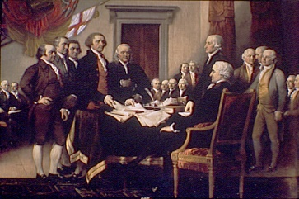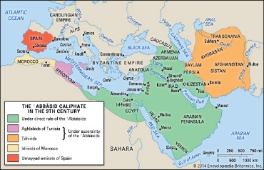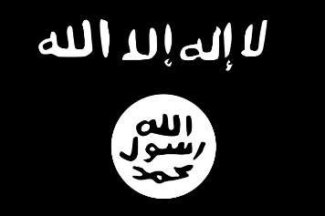
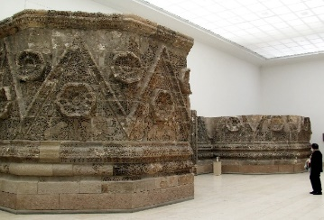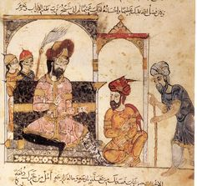

The word ‘Caliphate’ keeps getting thrown around these days as massive changes sweep the Middle East. So what was the Caliphate? Where did it come from? And what effect does the idea of this ancient civilisation have on the present? This talk looks into the story of how the Caliphate rose to power in 632 CE and separates fact from fiction. We will explore how effective the Caliphate was, some of the highs and lows of its 1300-year history, and how
the concept of the Caliphate illustrates the modern world.

